Allan Schwartz

Wed Aug 9, 2017

V1.1

# Notes on Clockwall “clock-module” PCB board.

## Breadboard View:

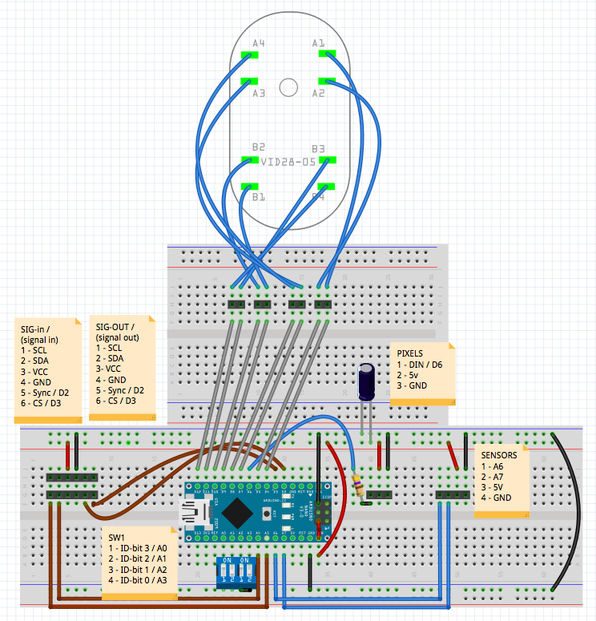

## Schematic View:

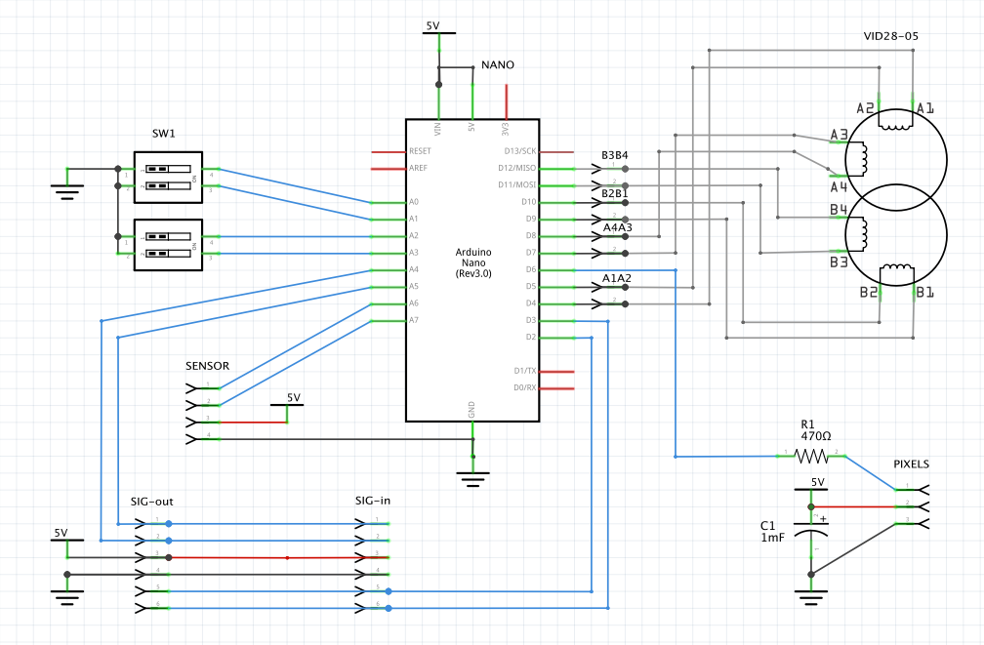

## Connectors:

### SIG-in & SIG-out

SIG-in and SIG-out carry the same signals.

They are designed for an I2C bus or a SPI bus (or both), plus power and ground.

On the schematic, I’ve drawn it as a 6-pin Male Header 0.100” (2.54mm) pitch.

In the production, we probably want something smaller, such as JST-PH series (2.0mm Pitch) or JST-XH series (2.54 pitch) connectors. Positive mechanical latching is an absolute requirement for the production board.

However, we also need a cheaper / easier development platform. Moreover, we don’t have any crimpers in-house yet. There are issues of power distribution which remain unresolved. (Specifically we don’t know if VCC and GND should be in a 26gauge/24gauge/22gauge cable).

We don’t know if VCC and GND will be distributed via a daisy chain or point to point. It depends on the total power draw of 4 of these “clock-module” boards.

For the development mini-build, we will have SIG-in & SIG-out on a standard 6-pin Male Header 0.100” (2.54mm) pitch. Using this method, standard Dupont connectors and ribbon cable can be used for the interconnects.

|  |  |  |
| --- | --- | --- |
| SIGNAL-IN connector |  |  |
| Pin 1 | SCL | A5 |
| Pin 2 | SDA | A4 |
| Pin 3 | VCC | Vin/5V |
| Pin 4 | GND | GND |
| Pin 5 | Sync | D2 |
| Pin 6 | CS | D3 |

### SWITCH 1

SW1 is a 4-position DIP switch similar to this:

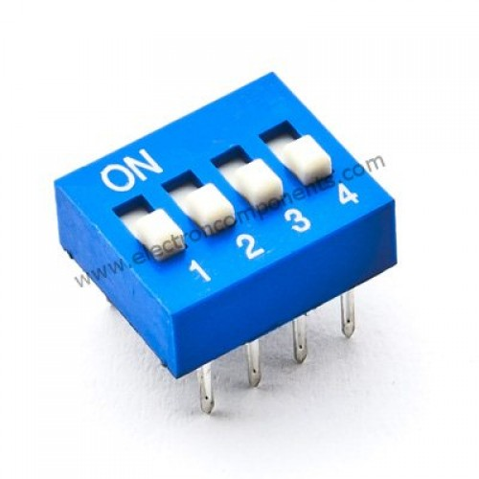

One side of the 4-switches is grounded. The other side is wired as follows:

|  |  |  |
| --- | --- | --- |
| SWITCH1 |  |  |
| 1 | ID-bit3 | A0 |
| 2 | ID-bit2 | A1 |
| 3 | ID-bit1 | A2 |
| 4 | ID-bit0 | A3 |

If it is easier (*i.e.* meaning fewer VIAs) to wire these pins reversed, with 1-A3, 2-A2, 3-A1, 4-A0, this is acceptable. Interpreting the pins is entirely a software function -- the ID bits will be decoded by the MCU.

### Headers TP-A1A2, TP-A3A4, TP-B1B2, TP-B3B4

These test point headers are 2-pin Male Header 0.100” (2.54mm) pitch.

There is no real pin1 orientation, so each test point is to be wired to the closest signal being tested on the motor VID28-05.

### Header PIXELS

This is a 3-pin Male Header 0.100” (2.54mm) pitch. This header is for attaching a NEO-Pixel ring with a 3-pin Dupont connector.

|  |  |  |
| --- | --- | --- |
| PIXELS CONNECTOR |  |  |
| 1 | Data | D6 through R1 |
| 2 | 5V | 5V |
| 3 | GND | GND |

### Header SENSOR

This is a 4-pin Male Header 0.100” (2.54mm) pitch. This header is for attaching either a hall-effect sensor or an optical sensor with a 3 or 4-pin Dupont connector.

|  |  |  |
| --- | --- | --- |
| SENSORS CONNECTOR |  |  |
| 1 | Analog Data1 | A6 |
| 2 | Data2 | A7 |
| 3 | 5V | 5V |
| 4 | GND | GND |

## Arduino Nano

Use an Arduino Nano Rev 3. Male headers are to be soldered to the underside of the Nano.

The PCB should have a pair of Female Header 0.100” (2.54mm) pitch, 15-pin connector, onto which the Nano can be mounted.

The ICSP connector on the Nano is not used. However, the ICSP pads are drawn on the component side of the silkscreen so that the Nano part can be oriented correctly when plugged in. For clearance purposed, if the ICSP connector has pins, they are to be removed.

The mini-USB connector of the Nano will be used to reprogram the Nano, so clearance to that connector is important.

## VID28-05

|  |  |  |
| --- | --- | --- |
| VID28-05 |  |  |
| 1 | A1 | D4 |
| 2 | A2 | D5 |
| 3 | A3 | D7 |
| 4 | A4 | D8 |
| 5 | B1 | D9 |
| 6 | B2 | D10 |
| 7 | B3 | D11 |
| 8 | B4 | D12 |

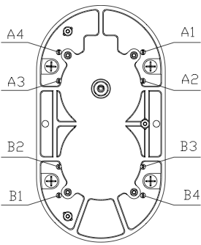

The VID28-05 has 8 connectors, 3 alignment holes, and a hole for the motor shaft.

Please refer to the mechanical drawing “*VID28-05_mechanical.pdf*”.

I have accurately drawn the above connectors and holes. Please refer to my drawing “*allan_vid28_pcb.svg*”. In this *svg* file, all dimensions are in mm.

The three 3mm alignment holes and the shaft hole for the VI28-05 should not be plated. This is in case we need to rework these holes in any way.

The shaft of the VID28-05 motor assembly must be in the exact center of the PCB.

Below is my analysis of the holes of the VID28-05. The VID28-05 is mounted on a 90w x 83h PCB so that the motor shaft is precisely centered. In the table below, all dimensions in mm.

|  |  |  |  |  |  |  |
| --- | --- | --- | --- | --- | --- | --- |
| *item* | *Hole  dia.* | *(x,y) with origin at*  *shaft center* | *(x1,y1) calculation with origin at part’s upper left corner* | *(x1,y1)* | *(x2, y2) calcu-lation with origin at PCB upper left corner* | *(x2,y2)* |
|  |  |  |  |  |  |  |
| shaft | 5.2mm | (0,0) | (35/2,   64/2 - 9.5) | (17.5, 22.5) | (90/2-17.5 + x1,   19 + y1) | (45, 41.5) |
|  |  |  |  |  |  |  |
| A1 | 1mm |  | (35/2 + 22.85/2,   64/2 - 23.24/2 - 7.7) | (28.925, 12.68) | (27.5 + x1,   19 + y1) |  |
| A2 | 1mm |  | (35/2 + 22.85/2,   64/2 - 23.24/2) | (28.925, 20.38) | (27.5 + x1,   19 + y1) |  |
| A3 | 1mm |  | (35/2 - 22.85/2,   64/2 - 23.24/2) | (6.075, 20.38) | (27.5 + x1,   19 + y1) |  |
| A4 | 1mm |  | (35/2 - 22.85/2,   64/2 - 23.24/2 - 7.7) | (6.075, 12.68) | (27.5 + x1,   19 + y1) |  |
|  |  |  |  |  |  |  |
| B1 | 1mm |  | (35/2 - 22.85/2,   64/2 + 23.24/2 +7.7) | (6.075, 51.52) | (27.5 + x1,   19 + y1) |  |
| B2 | 1mm |  | (35/2 - 22.85/2,   64/2 + 23.24/2) | (6.075, 43.62) | (27.5 + x1,   19 + y1) |  |
| B3 | 1mm |  | (35/2 + 22.85/2,   64/2 + 23.24/2) | (28.925, 43.62) | (27.5 + x1,   19 + y1) |  |
| B4 | 1mm |  | (35/2 + 22.85/2,  64/2 + 23.24/2 +7.7) | (28.925, 51.52) | (27.5 + x1,   19 + y1) |  |
|  |  |  |  |  |  |  |
| align1 | 3mm | (-9, -25) | (35/2 - 9,  64/2 - 25) | (8.5, 7) | (27.5 + x1,   19 + y1) | (36, 26) |
| align2 | 3mm | (+12, 0) | (35/2 + 12,   64/2) | (29.5, 32) | (27.5 + x1,   19 + y1) | (57, 41) |
| align3 | 3mm | (-9, +25) | (35/2 - 9,   64/2 + 25) | (8.5, 57) | (27.5 + x1,  19 + y1) | (36, 76) |

## Other Components

### ***R1***

R1 is a 470 ohm, 1/4watt, +/-5%, through-hole (THT), Axial Carbon Film.

With 300 mil pin spacing?.

### ***C1 & C2***

C1 & C2 are both 470μF/25V Electrolytic Decoupling Capacitor.

These can be purchased in a number of sizes. The board has 100 mil spacing.

### ***Standoffs***

Mounting holes in the corners should be sized for 6/32 mounting screws or 3.5mm mounting screws or standoffs. They should be plated and grounded

## PCB

The PCB should be standard, green 1.6mm, with top (component) and bottom silkscreen layers.

All components should be labeled. Pin 1 is always on the left and labeled for horizontally oriented parts. Pin 1 of SW1 does not need to be labeled. The components are outlined as above, and part labels visible as above on the component side of the silkscreen.

Add “©2017, CodeValue Ltd.” on the silkscreen component layer.

Add “CLOCK-MODULE, V1.0” on the silkscreen component and bottom layer.

Label the PIXELS header and the SENSOR header on both sides of the PCB, including pin1.

Here is a suggested board layout:

